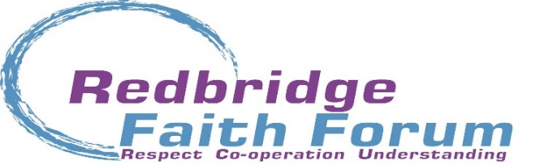
Press Release – for immediate issue.
Date 8th March 2016

‘Being Part of the Solution’
Health and Wellbeing Open Forum
Held at the Buddhist Cultural Centre, Balfour Road, Ilford
Tuesday 8th March 2016
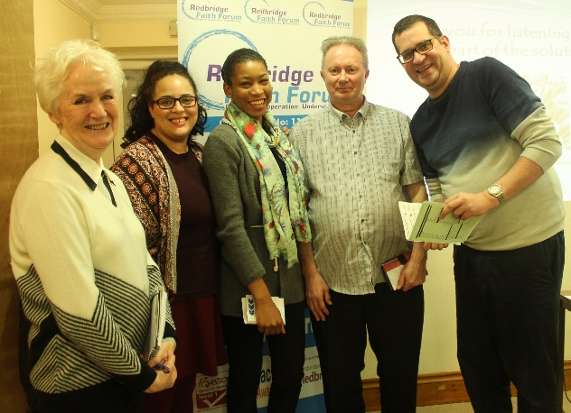
At the second in a series of three events, people from across the Borough came to an evening focussing on Health and Wellbeing at the Buddhist Cultural Centre, Balfour Road. The event, jointly organised by Redbridge Faith Forum (RFF) and Redbridge Concern for Mental Health (RCMH) marked International Women’s Day. Jacquie Grieve, Chair of RFF welcomed all to the event in her opening address and thanked members of the Buddhist community for providing plentiful and delicious refreshments as well as a warm welcome.
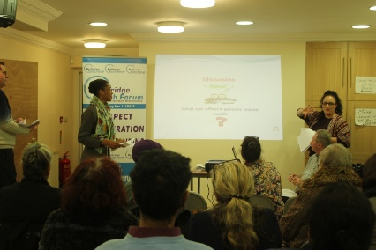
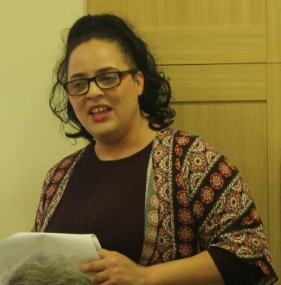
The team from RCMH, which consisted of Charmaine Harris, Appelonia Wilson, Ian Fullbrook and Chris Day, gently brought their own experiences of being a ‘service user representative’. Through a series of often surprising statistics the assembled group learnt about the real effect on mental ill health and how one in four people in the UK will be directly affected by this and, for example, the UK has the highest incidence of self-harm in Europe. The event aimed at raising awareness and removing the stigma often attached to Mental Ill Health was open to all. They learnt also that men are less likely to seek help with often tragic results. Suicide in men is still the highest cause of death with middle aged men being most at risk. Charmaine Wilson said during her presentation, ’When we see these stats, the world can seem a scary place’.
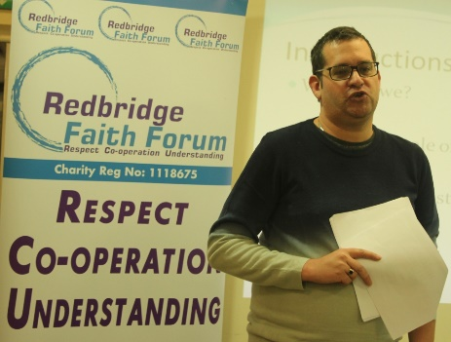
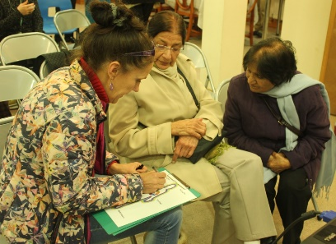
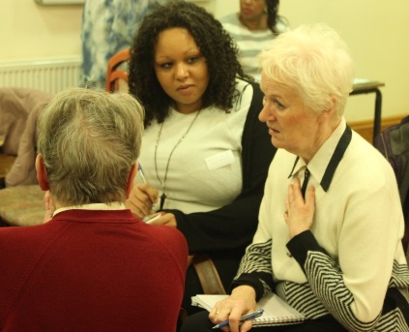
Throughout the evening, the team gently provided practical advice on how individuals can both help and find support in a range of situations. How it is important to pick up on what is happening in a person’s life and that helping with basic tasks like cooking a meal or washing up can be a great support when someone is unwell. During his presentation, Ian Fullbrook made the point that people don’t choose to be unwell and phrases like ‘pull yourself together’ are of no help at all. Sometimes, listening is all that is required and is all part of us ‘being human’. Charmaine added, ‘Listening is about patience, having the patience and allow the person time. Listening is about patience, just being there’. Using the acronym PACE she added, ‘Patience Always Conquers Eventually’.
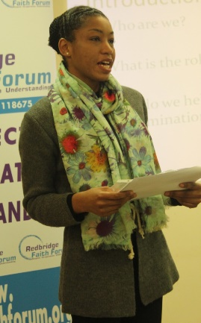
The group also spent some time explaining how mental ill health can be stigmatised and that how we use language is important in approaching how we can sensitively and effectively understand and deal with the real impact of mental ill health on the individual, their families and society in general.
In their conclusion, the team provided information regarding a wide range of support organisations based in Redbridge who can proved help in many situations. This was also provide in the form of a pamphlet. ‘This is not about psychiatry, but being human at heart’. The final words from Appelonia Wilson invited all not to be simply bystanders but to ‘Be Part of the solution’.
More information can be provided either from RFF or RCMH.
A full programme of future events is available from the RFF Office. We thank the Reverend Hemaratna and his team at the Buddhist Cultural Centre for providing the venue and refreshments
For more information contact RFF on 020 8708 2478 or email faithforum@redbridge.gov.uk
End.

