“HOMELESSNESS & ROUGH SLEEPERS” – Redbridge Faith Forum Network Meeting 31 January 2017
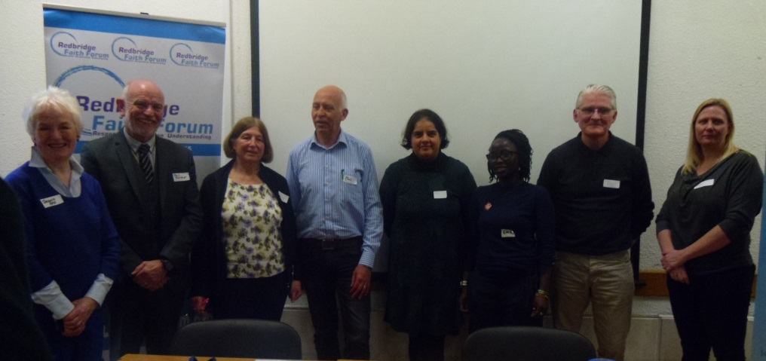
Redbridge Faith Forum held its first network meeting on 31st January 2017 in the Gloucester Room of Redbridge Central Library – over 85 people attended this very informative meeting and were encouraged to hear how well local services work together to support homeless people and sleeping rough but also concerned to hear that homelessness is continuing to rise. A report of the meeting follows:-
Phil Butcher, vice-Chair of RFF welcomed everyone to the meeting and explained that the speakers were all going to be allocated 5-7 minutes to make a short presentation about the services of their organisation and there would be times for questions and answers later in the programme.
Presentation 1 – Lou Holland of SHP Housing
Lou Holland of Single Homeless Project (SHP) currently manages
- the Street Outreach Team which operates between 10pm and 5 am
- Jason Lee House in York Road an 18 bed hostel that was formally the Redbridge Night Shelter (set up by Ilford churches) – caters for people with quite complex support needs including substance misuse and provides access to health & benefit support
- Green Lane hostel – a 12 bed provision for those who have successfully completed assessment at Jason Lee House
SHP supports people (7,000 over 13 different boroughs) in a number of ways
- to move into private rented accommodation,
- to detox by using individually tailored detox rehabilitation programmes using a psychological approach trying to work around trauma using
- running an opportunities programme with employment and training options
- floating support service provided in homes
SHP wants to develop partnerships as homelessness is increasing. A lot of recovering people do find support in faith communities and SHP would be glad to strengthen links with faith groups, and would welcome visits to the hostels. SHP receives funding from the local authority but is also glad to receive donations and does have links with food banks. SHP also use volunteers with full-time and part-time opportunities.
Presentation 2 – Phil Herbert of The Welcome Centre, Healthy Living Projects
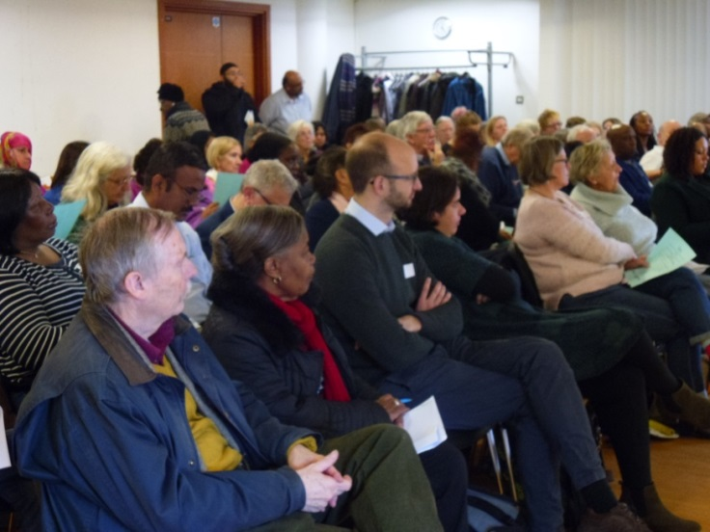
The Welcome Centre was started in 2001 by a local Baptist church as a faith based charity in response to emerging needs in the community – poverty, newly arrived people and the increase in homelessness. It operates as a day centre and is open Monday-Friday providing basic services such as food, showers, laundry service. Most users have physical health addictions and two support workers work assisting with benefit claims and liaising with SHP and LBR for housing; a nurse is available to give health assessments and checks and any unresolved immigration issues are referred to RAMFEL. The Centre is supported by 30 volunteers and receives support from many diverse faith groups and local schools. Any excess donations of food are passed to the foodbank and this is a reciprocal service. The centre is managed by Sonia who has challenging work but efforts are channelled through existing agencies that have experience in the borough – everyone acknowledges that no one organisation can do everything but each can all do something with no need to reinvent the wheel.

Presentation 3 – Ritah Kambona, Project Co-ordinator, Salvation Army Night Shelter
The Salvation Army Night Shelter has opened during the last 7 years between December to March each winter – 55 people were supported last winter. The Salvation Army wants to work to change the situation and not just treat the symptoms and believe shelters should be a temporary solution and not a permanent feature. The Salvation Army and Ramfel are liaising on a project called Project Malachi – a housing first project aimed at people with no recourse to public funds - leaflets available on the table. 36 out of the 42 people currently using the shelter have been sleeping rough for two years or more and have very complex situations. Service provision is only given credibility if working towards justice – there is a real need to find solutions and speak out for justice.

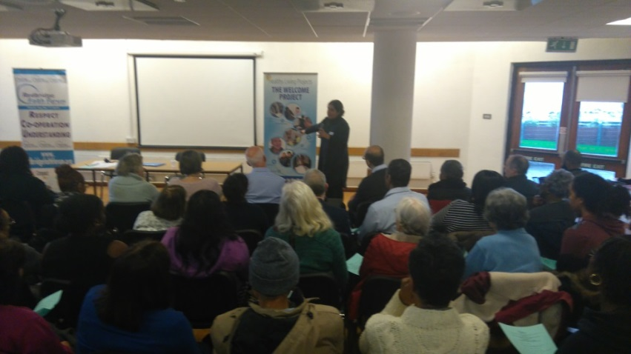
Presentation 4 - Rita Chadha, Chief Executive Officer, Ramfel
Ramfel is the Refugee and Migrant Forum of East London and Essex and sees anything between 100 and 200 people a week and provides a level 3 immigration advice which is free legal representation equivalent to seeing a solicitor. Ramfel also provides access to employment and benefits, health and social care signposting, offers training and support to the voluntary sector and partners to understand what immigration means. Redbridge is also fortunate in having the Immigration Task Group set up under the provisions of the Fairness Commission and chaired by Councillor Littlewood. Ramfel also does a lot of campaigning and has in partnership with the Salvation Army previously challenged the Met Police over “Operation Sleeping Bag” in 2013-14 when sleeping bags were taken away from homeless people. Processes are now much more co-ordinated. Rita illustrated the work of Ramfel using the case history of a service user who had successfully transformed his life with the support of SHP/Salvation Army/Ramfel who had campaigned on his behalf to be given time to remain in the country – he was now free of addiction, reconciled with family and working as well as volunteering at SHP. Rita confirmed that asylum seekers are in most cases entitled to some support and refugees have housing rights.

Presentation 5 – Wendy Taylor, Sunday Drop in Service, SS Peter & Paul
This Sunday drop in service operates from SS Peter & Paul Church in High Road Ilford and provides soup sandwiches and hot meals to homeless people – averaging 42 a week although numbers can vary between 32-60.
The guests all have complex needs and the service is provided by volunteers. New volunteers are welcome and are asked to call in first to visit the drop in service to see if this type of voluntary work would suit them.
Presentation 6 - Mark Brennan, Shelter Projects Co-ordinator, Housing Justice
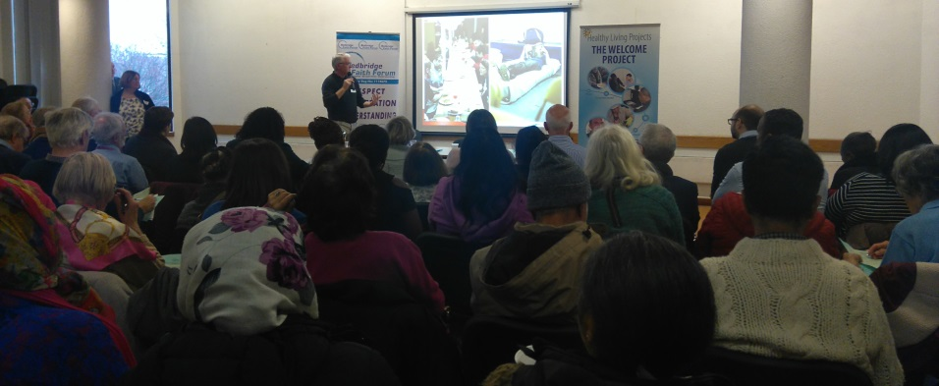
Mark showed a powerpoint presentation http://redbridgefaithforum.org/wordpress/?p=969 outlining the work of Housing Justice and its 25 years’ experience of working with shelter projects and had brought along leaflets about church and community night shelters. Homelessness was an increasing problem often caused by a combination of relationship breakdown (may be family, friends, social contacts) and the ending of short term assurances for people renting – there is often a journey of events leading to the final step pf homelessness. There is also an issue of “hidden homelessness” with some people spending nights riding night buses or sleeping on friends sofas or sheltering inside public places. The Shelter network currently has 77 projects using 700 volunteers across the circuit. All London boroughs apart from Sutton and Richmond have shelters with some boroughs having more than one eg Ealing & Southall, and Islington where a specific shelter has been set up for 16-23 years olds run by the Pilion Trust.
Further information about the network of shelters together with some excellent videos are http://www.ecwns.org.uk/about/
http://thisisgrowth.org/
The audience were reminded that if anyone is concerned about a rough sleeper they can call Streetlink on 0300 500 0914 or log onto their website at http://www.streetlink.org.uk to give the location of the rough sleeper and details will be passed to the local outreach team who will go out to check on their welfare.

The next RFF Network Meeting will be held in the Gloucester Room 11.45am -1.30pm on Tuesday, 25th April 2017 – save the date!

